Staffs Profiles

Full Name* Tenagnework Dilnessa Mulualem

Gender* Female

Email* tenagneworkd@gmail.com

Status*(On-duty/ On study leave..) On duty

Current Academic Rank* Lecturer

Date Current Academic Rank entitled* 08 /04/2016 G.C

Previous Academic Rank entitled* Assistant Lecturer
(N.B:-Only to be used for internal purpose. Not to be disclosed for public)
(entry has to be according to the Academic Rank precedence and the dates chronological order in G.C calendar)

1. Assistant Lecturer 01/03/12 G.C 07/04/2016 G.C
Academic Rank Start Date End Date

2. Lecturer 08/04/2016 G.C
Academic Rank Start Date End Date

3.
Academic Rank Start Date End Date

Example:-
Assistant Lecturer | ------ | 2005/09/01 G.C to 2007/08/30 G.C
Lecturer | ------ | 2007/09/01 G.C to 2009/08/30 G.C
Assistant Professor | ------ | 2009/09/01 G.C to 2010/11/30 G.C

If status is "On Study leave" ,the following information have to be also incorporated :-
(N.B:-Only to be used for internal purpose.Not to be disclosed for public)
Country
University
Area of specialization
Date of Leaving
Expected Date of reinstate

Qualification* MSc (eg.BSC,MSC, ...along with any certifications [if any])

Specialization*:-Clinical Midwifery

Date of Employment*:- 01/03/2012 G.C

Passports Size Photo*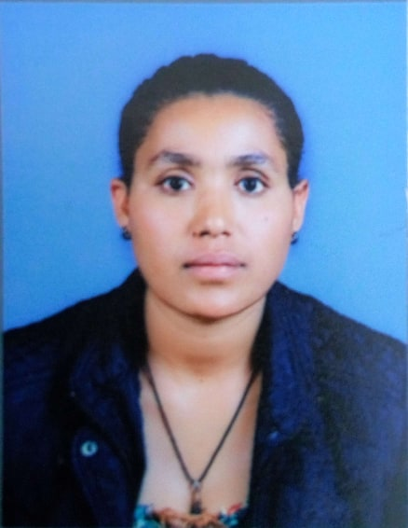

Profile*:-(includes Educational Biography, experience, research, and administration position engaged in Wollo University)

- Bsc in Midwifery at university of Gondar
- Msc in clinical Midwifery at university of Gondar
- I have worked for 3 years in Dessie referral hospital. Starting from 01/03/2012G.C till now I am working in Wollo University.

Research/Project engaged or in Progress[if any]:-
[Possible to enter Research interest if the staff is interested]
- A study on women preference on cesarean delivery and associated factors among mother attend in Antenatal clinic , in Dessie town , across sectional study
- Adverse birth outcome and associated factors among mother delivered in Dessie referral hospital, a cross sectional study

Lists of all Publication[if any] (includes Articles/Books/Books' Chapter/Proceedings)
PublicationTitle
- Proportions of Pre-Cancerous Cervical Lesions and Its Associated Factors among Women Clients in the Age Group of 30-49yrs in Gynecology Ward of Dessie Referral Hospital and FGAE, North-East Ethiopia, 2016
- Proportion of failed induction of labor and associated factors among women undergoing induction of labor in Dessie referral hospital; Northeast Ethiopia a cross sectional study.(on Galley proof level)
- Timely Initiation of Breastfeeding and Its Determinants among Nursing Mothers in Bahir Dar City, Northwest Ethiopia: A Cross Sectional Study(In galley proof level)
_

Publication details

Community Services
- Awareness creation on Drug utilization during pregnancy at Desssie and Kombolcha Health center

- Awareness creation on Shifting family planning user to long acting family planning for south wollo health care provider

N.B Fields marked with "*" are mandatory

